<Project Name>

Version <1.0>

[Note: The following template is provided for use with the Rational Unified Process. Text enclosed in square brackets and displayed in blue italics (style=InfoBlue) is included to provide guidance to the author and should be deleted before publishing the document. A paragraph entered following this style will automatically be set to normal (style=Body Text).]

[To customize automatic fields in Microsoft Word (which display a gray background when selected), select File>Properties and replace the Title, Subject and Company fields with the appropriate information for this document. After closing the dialog, automatic fields may be updated throughout the document by selecting Edit>Select All (or Ctrl-A) and pressing F9, or simply click on the field and press F9. This must be done separately for Headers and Footers. Alt-F9 will toggle between displaying the field names and the field contents. See Word help for more information on working with fields.]

Revision History

|  |  |  |  |
| --- | --- | --- | --- |
| **Date** | **Version** | **Description** | **Author** |
| <dd/mmm/yy> | <x.x> | <details> | <name> |
|  |  |  |  |
|  |  |  |  |
|  |  |  |  |

Table of Contents

1. Introduction 3

1.1 Purpose 3

1.2 Scope 3

1.3 Overview 3

2. Project Overview 3

2.1 Project Purpose, Scope, and Objectives 3

2.2 Assumptions and Constraints 3

2.3 Project Deliverables 3

3. Project Organization 3

3.1 Organizational Structure 3

3.2 Roles and Responsibilities 3

4. Management Process 3

4.1 Project Estimates 3

4.2 Project Plan 3

4.2.1 Phase Plan 3

4.2.2 Iteration Objectives 3

4.2.3 Releases 3

4.2.4 Project Schedule 3

4.2.5 Project Resourcing 3

4.3 Project Monitoring and Control 3

4.3.1 Requirements Management 3

4.3.2 Reporting and Measurement 3

4.3.3 Risk Management 3

4.3.4 Configuration Management 3

# Introduction

[The introduction of the **Software Development Plan** provides an overview of the entire document. It includes the purpose, scope, definitions, acronyms, abbreviations, references, and overview of this **Software Development Plan**.]

## Purpose

[Specify the purpose of this **Software Development Plan**. The text below is provided as an example**.** ]

The purpose of the *Software Development Plan* is to gather all information necessary to control the project. It describes the approach to the development of the software and is the top-level plan generated and used by managers to direct the development effort.

The following people use the *Software Development Plan*:

* The **project manager** uses it to plan the project schedule and resource needs, and to track progress against the schedule.
* **Project team members** use it to understand what they need to do, when they need to do it, and what other activities they are dependent upon.

## Scope

[A brief description of the scope of this **Software Development Plan**; what Project(s) it is associated with and anything else that is affected or influenced by this document. The text below is provided as an example.]

This *Software Development Plan* describes the overall plan to be used by the <project name> project, including deployment of the product. The details of the individual iterations will be described in the Iteration Plans.  
The plans as outlined in this document are based upon the product requirements as defined in the *Vision Document*.

## Overview

[This subsection describes what the rest of the **Software Development Plan** contains and explains how the document is organized. The text below is provided as an example.]

This *Software Development Plan* contains the following information:

Project Overview — provides a description of the project's purpose, scope, and objectives.  It also defines the deliverables that the project is expected to deliver.

Project Organization — describes the organizational structure of the project team.

# Project Overview

## Project Purpose, Scope, and Objectives

[A brief description of the purpose and objectives of this project and a brief description of what deliverables the project is expected to deliver.]

## Assumptions and Constraints

[A list of assumptions that this plan is based and any constraints, for example. budget, staff, equipment, schedule, that apply to the project.]

## Project Deliverables

# Project Organization

## Organizational Structure

The project team:

## Roles and Responsibilities

|  |  |
| --- | --- |
| **Person** | **Role** |
| Thanh Long, Project Manager | Responsible for maintain the Project store management, keep the project team focused on the right goal. |
| Nhật Phương, Designer | The designer creates the interface of the software, and defines the operations, attributes and relationships of entities or classes. |
| Tuấn Phùng, Architect | Identify the overall structure for the project, provide design sketches and details, prepare budget. |
| Khánh Vy, Business Analyst | Working directly with customers, get the requirements from them and transfer to team; analyses the effect of changings to the process. |
| Văn Quang, Tester | Responsible for executing testing, detect the bug, evaluation and recovery system from errors. |

# Management Process

## Project Estimates

The Inception phase of project will take 2 weeks.  
The Elaboration phase of project will take 2 weeks.  
The Construction phase of project will take 4 weeks.

## Project Plan

### Phase Plan

* WBS for this project:

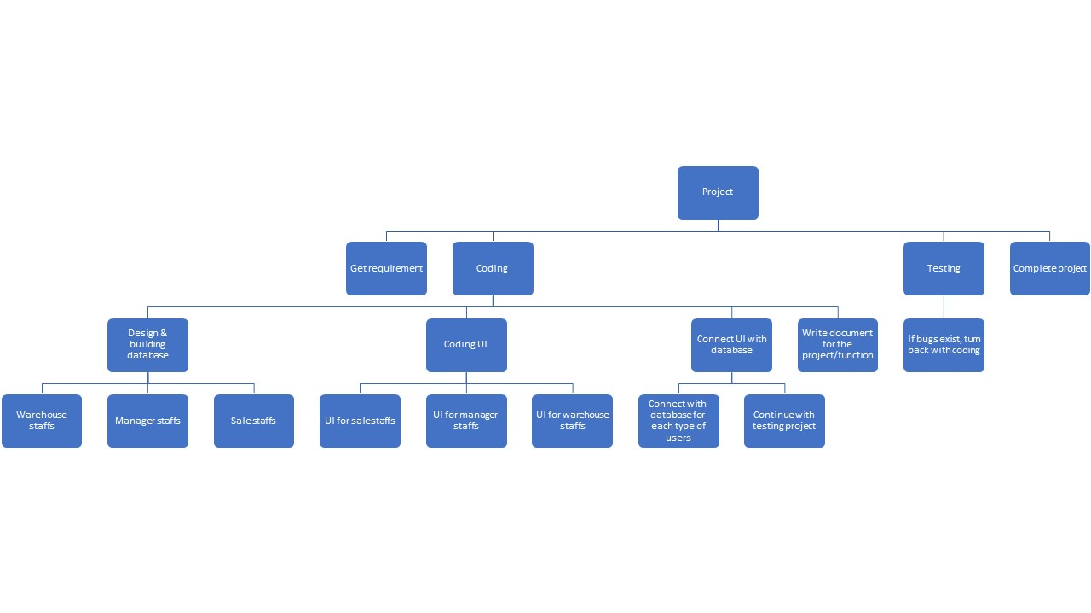

* Gantt chart:

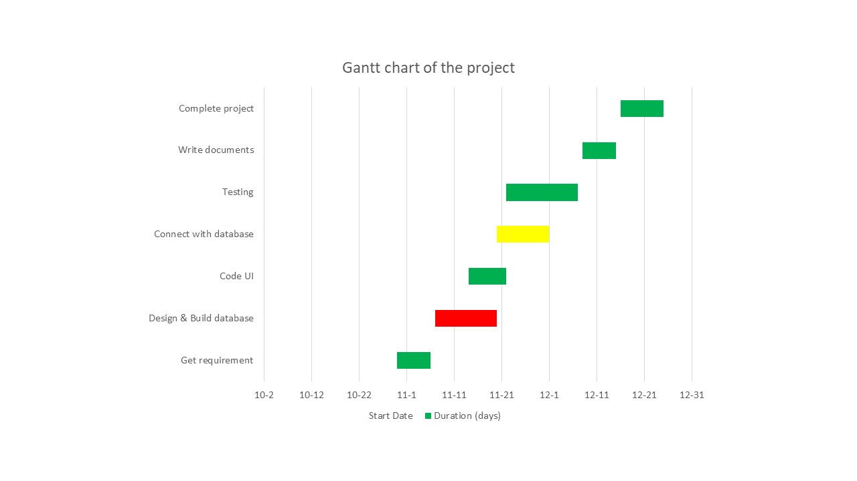

### Iteration Objectives

|  |  |  |  |  |
| --- | --- | --- | --- | --- |
| **Phase** | **Iteration** | **Description** | **Associated Milestones** | **Risks Addressesd** |
| Inception | Preliminary Iteration | Defines business model, product requirements, project plan, and business case. | Business Case Review | Identify user requirements, scope of project. |
| Elaboration | Develop Architectural Prototype | Completes analysis and design for all use cases. | Architectural Prototype |  |
| Construction | C1: Develop Beta | Implement function and usecases. | Beta | Some key features from types of user. |
|  | C2: Develop Initial Release | Implement and test other usecases, fix bugs from Beta version. Continue developing remain functions | Software | Improve quality of product.  All features of users should be implemented. |
|  | C3: Develop Full Release | Fix bugs from Initial version. Develop fully system. Improve performance. | Software Released | All functions of system developed fully. |

### Releases

|  |  |  |
| --- | --- | --- |
| **Version** | **Description** | **Note** |
| Alpha | Basic login feature and UI, connect database. |  |
| Beta | Basic features(Insert bill, register member) for users who are sale staff. Basic features for users who are storage staff.  Basic features for manager(manage all staff of store) | Demo |
| 1.0 | Improve UI. Improve features for all types of user(such as employee can check the static of product,…) | Release |
| 1.1 | Manager can require and check the report of product, storage, financial. |  |

### Project Schedule

* Schedule will be updated weekly.

|  |  |  |  |
| --- | --- | --- | --- |
| Start date | Target date | Goal | Result |
| 18/10/2019 | 28/10/2019 | Get requirements, write description about project. | Identify user requirements. |
| 28/10/2019 | 11/11/2019 | Assign roles for members. Writing project plan, vision. Writing report weekly. Group meeting through Zoom. |  |
| 11/11/2019 | 18/11/2019 | Analysis and design for all use cases |  |
|  |  |  |  |
|  |  |  |  |
|  |  |  |  |

### Project Resourcing

 [Identify the numbers and type of staff required here, including any special skills or experience, scheduled by project phase or iteration.

 Describe how you will approach finding and acquiring the staff needed for the project.

 List any special training project team members will require, with target dates for when this training should be completed.]

## Project Monitoring and Control

 [The following is a checklist of items to consider:

* Requirements Management : Specify the information and control mechanisms which will be collected and used for measuring, reporting, and controlling changes to the product requirements.
* Reporting and Measurement: Describe internal and external reports to be generated, and the frequency and distribution of publication. Specify which metrics should be collected and why.
* Risk Management: Describe the approach that will be used to identify, analyze, prioritize, monitor and mitigate risks. Include a list of risks and their current status.
* Project Close-out: Describe the activities for the orderly completion of the project, including staff reassignment, archiving of project materials, post-mortem debriefings and reports, and so forth.
* Configuration Management: Describe the process by which problems and changes are submitted, reviewed, and dispositioned. Describe how project or product artifacts are to be named, marked, and numbered, including hardware, system software, Commercial-Off-The-Shelf (COTS), plans, models, components, test software, results and data, executables, and so on. Describe retention policies, and the back-up, disaster, and recovery plans. Also describe how the media is to be retained—online, offline, media type, and format.

The text that follows is provided as an example.]

### Requirements Management

The requirements for this system are captured in the Vision document. Requested changes to requirements are captured in Change Requests, and are approved as part of the Configuration Management process.

### Reporting and Measurement

Updated cost and schedule estimates, and metrics summary reports, will be generated at the end of each iteration.

The Minimal Set of Metrics, as described in the RUP [Guidelines: Metrics](..\..\..\process\modguide\md_metri.htm), will be gathered on a weekly basis. These include:

Earned value for completed tasks. This is used to re-estimate the schedule and budget for the remainder of the project, and/or to identify need for scope changes.

Total defects open and closed – shown as a trend graph. This is used to help estimate the effort remaining to correct defects.

Acceptance test cases passing – shown as a trend graph. This is used to demonstrate progress to stakeholders.

In addition, overall costs will be monitored against the project budget.

### Risk Management

Risks will be identified in Inception Phase using the steps identified in the RUP for Small Projects activity “Identify and Assess Risks”. Project risk is evaluated at least once per iteration and documented in this table. The risks of the greatest magnitude are listed first in the table.

|  |  |  |
| --- | --- | --- |
| **Risk Ranking (High, Medium, Low)** | **Risk Description and Impact** | **Mitigation Strategy and/or Contingency Plan** |
|  |  |  |

### Configuration Management

Appropriate tools will be selected which provide a database of Change Requests and a controlled versioned repository of project artifacts.

All source code, test scripts, and data files are included in baselines. Documentation related to the source code is also included in the baseline, such as design documentation. All customer deliverable artifacts are included in the final baseline of the iteration, including executables.